**Housing Assistance (Bridge Funding) Program**

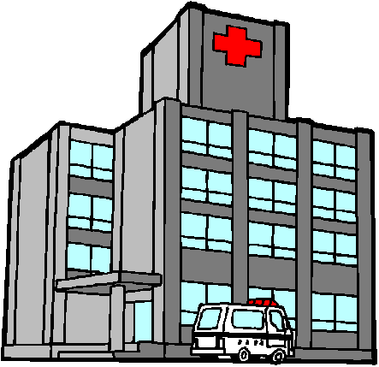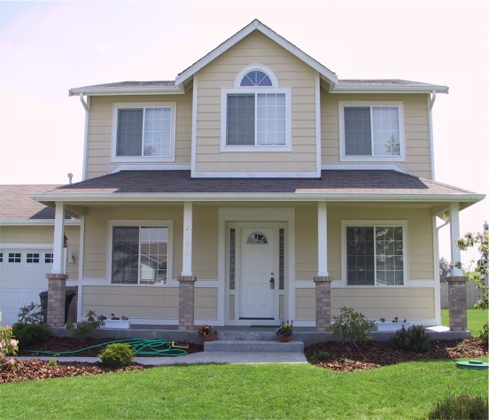

**NOW ACCEPTING REFERRALS!!**

**What is the Housing Assistance Program?**

* A rental assistance program designed to assist individuals with mental illness/or substance abuse issues transition from state-run psychiatric facilities back into the community.

**Who is Eligible for the Program?**

* Program eligibility includes those individuals with a mental illness who are at risk of homelessness or re-institutionalization. **Priority** will be given to those who are exiting an institution such as a state-run or contracted psychiatric facility, nursing facility as referred through the PASRR Level II process, a correctional facility or individuals who are homeless/chronically homeless.

**What is the Diagnosis Criteria?**

* Individual must have a psychiatric diagnosis, which may be accompanied by a co-occurring substance use disorder.

**What are the Determining Qualifications for the Program?**

* Must have a psychiatric/substance use diagnosis, indigent, and at risk at homelessness.

**Are the Services Long Term or Short Term?**

* Services are short term and typically offered up to 3 months for transitional supports

**What are the Program Requirements?**

* All individuals must apply for Social Security and Medicaid prior to applying (must have proof-**IN WRITING**).

**IF YOU KNOW SOMEONE WHO QUALIFIES FOR THE ABOVE ASSISTANCE**

CONTACT:

LaShonda Gedward DeRouen

Housing Director

[lashondamhal@gmail.com](mailto:lashondamhal@gmail.com)

318-582-9627

